Graded Unit 2

small business System

Inception Phase

Forth valley College

Darren Stewart - 538981

Table of Contents

**1 Interpretation of the project brief** 3

1.1 Solution 1 3

1.2 Solution 2 4

1.3 Solution 3 4

1.4 Chosen Solution 4

**2 Functional and Non-Functional Requirements** 6

2.1 Functional requirements 6

2.2 Non-Functional Requirements 7

2.3 Use cases 9

2.3.1 Initial Top-Level Use Case Diagram 9

2.3.2 Revised top-level use case Diagram 10

2.3.3 Initial use case descriptions 10

2.3.4 Design stage use case descriptions 11

**3 Information gathering techniques** 12

3.1 Client Interviews 12

3.1.1 Interview questions 13

3.2 Research performed on similar applications 15

3.3 Questionnaires 16

3.3.1 Questionnaire description for client 17

3.3.2 Questionnaire Description – for wider audience 17

3.3.3 Questionnaire form – for client 17

3.3.4 Description of the application for the questionnaire 18

3.3.5 Questionnaire form – for wider audience Template 18

3.3.6 Questionnaire form – for wider audience Finalized 20

3.3.7 Questionnaire - feedback 20

**4 Project aim** 27

**5 Resources and materials required** 27

5.1 Hardware 27

5.2 Software 28

5.3 Materials 29

5.4 Books, journals, tutorials 30

**6 Deliverables** 31

6.1 Documentation for feasibility meeting 31

6.2 Inception phase report 31

6.3 User Interface design wireframes 31

6.4 Solution Phase Planning report 31

6.5 Application prototype 32

6.6 Development stage documentation 32

6.7 Evaluation Report 32

**7 Information sources** 32

# **1 Interpretation of the project brief**

I have been approached by a small game retailer that is based in the uk who are looking for a software developer to build them an application to help them expand their business.

The application that the company wants build is a small business application with a wide range of features that help them track important details about how their business is performing. The features that the company want to be included in the application is that is for the application to be able to cover sales invoicing and for them to be able to control their stock in real time. The company wants the application to produce a sales invoice for each transaction and to update their stock in real-time.

The application should display information on screen and to also be able to produce paper reports that detail their daily, weekly, monthly, quarterly and annual sales analysis, VAT analysis, stock turnover and stock outages. The company wants to also be able to display customer, product, supplier and invoice information they want this to include transaction logs to have an option to print any of the transaction logs.

They want the application to be able to work on computers with low specifications running windows xp, Linux or Mac OS X or newer the application should either be a console-based application or have a graphical user interface.

## Solution 1

The first option to reach a solution would be to build a web-based application with a simple easy to use user interface connecting the website to a data base in order to store the businesses information.

Some advantages of using this solution would be that it is easily accessible since for as long as the device you are using has internet access you would be able to access the application another advantage that using this method would provide a good user experience as it is easy to design the website to work across different platforms and different screen sizes. Users would be using the most up to date version of the software since all be using the same version of the application since it is accessed on the web using a URL.

Some disadvantages to using this solution are that if you don’t internet access you are unable to use the application another disadvantage is that using a webpage would run slower since is accessed on the web rather than being accessed locally There is also a security risk when developing web-based application since everything would be stored online. There is also the issue of people using different browsers meaning that extra time would need to be spent to develop the app to ensure that the application works of a range of different browsers.

(Fox, 2018)

## 1.2 Solution 2

The Second option to reach a solution would be to build a console-based application that will be able to be linked up to a data base to store the business information

An advantage to using this solution is that the application would take less time to build because there is no need to spend time building the user interface. Console based applications also require less resources to run compared to using a graphical user interface

Disadvantages to using this solution are that the application would not look visually appealing and could also be confusing for users to follow how to use the application. The application would also not be as portable as solution one since it would be stored on the device it was installed on.

## 1.3 Solution 3

The third solution would be to build a desktop application with a simple easy to use graphical user interface which will be able to communicate with a data base that stores the businesses information.

Advantages of using this solution are that the application would be able to be designed in a way for it to be easy for the user to use and be visually appealing to use. The since the application is only accessible to people who have access to the program it would be a lot more secure to use than building a web-based application.

Disadvantage to using this solution are that due to making the application less portable also using a graphical user interface can be harder to run on a computer with low specifications the application may also take a longer time to build since you would spend time to develop and test a user interface to ensure that It works properly.

(Rehman, 2017)

## 1.4 Chosen Solution

After comparing each of the potential solutions I have decided that I will be using solution 3 to build the application the application that I am developing will be a windows-based application that will run on windows xp or newer. I have decided to build the application using Java and I will be building a data base that is able to link to the java program that will be able to use sql in the java program to return data that I want to retrieve from the data base to build the user interface of the application I will be using java fx.

Out of the options I had for building the user interface I concluded that using a graphical user interface would be the best choice to display information generated by the application. the reason that I am using a graphical user interface rather than making it a console based application is because the application is required to be simple to use and I feel that using a console based application may have been difficult for employees to pick up how to use the application another reason that using is the best decision is that they are a lot more customisable and are much more visually pleasing to look at. have decided to use a graphical user interface while using a console-based application offers very little options of how to improve the look of the application. The way that I will be building the user interface is to use java fx using scene builder.

The reason That I have decided to use java to build the program is because java is the programming language that I am most familiar with and know that I will be able to implement the features that are required. I will be able to connect the data base that I will build to the java program by using JDBC driver this will allow the java program to communicate allowing the data base to be accessed by the program to retrieve any information needed and save any changes that are made to the data base since a data base is being used no data will be lost if the application is switched off. Another reason that I will be building the application in java is due to it being a language that has been around for a long time meaning that I will be able to take advantages of a wide range of different library functions that java has available.

The way that the management of the stock the company holds will function is to store the items that they sell in a data base. Then use buttons that navigate the user to a page which will have features that allows the user to update stock this will allow the stock to be updated in real time and inform the user if any stock outages, there will also be a button that allows the user to generate stock reports.

To handle the generate of the sales report each type of report will have a button that generates the type of the report that they want the way that the reports will be generated is to take the data stored in the data base.

The way that sales reports will be generated is this will then run a command that will retrieve the information from the database and display it on screen or allow the user to print the report.

The way that the display of information to the screen will be handled is to take the information about their customers, products , suppliers and invoices that are currently stored in the data base and then store it in the program allowing me to be able to display the information on the screen and also allowing the user to have the option to print as well.

# **2 Functional and Non-Functional Requirements**

## 2.1 Functional requirements

1. Employees are required to log in to use the system. (UC 1)
2. Produce sales Invoice for each Transaction. (UC 2)
3. Customer first name
4. Customer last name
5. Customer address
6. Customer email address
7. Name of product they bought
8. Cost of the product
9. Quantity sold
10. Invoice Id
11. Update stock in real time. (UC 3)
12. Generate sales reports based on. (UC 4)
13. daily sales
14. weekly sales
15. monthly sales
16. Quarterly Sales
17. Annual Sales analysis
18. Vat analysis
19. Stock Turnover
20. Profitability
21. Generate Stock Report. (UC 5)
22. Reorder report
23. Stock outage
24. On-Screen client displays of. (UC 6)
25. Customer Information
26. Product Information
27. Supplier Information
28. Invoice Information
29. Transaction Logs
30. Print generated reports. (UC 7)
31. Print report generate from (FR4 A-H)
32. Print report generate from (FR5 A-B)
33. Print report generate from (FR6 A-D)

## 2.2 Non-Functional Requirements

1. Reports should be available on screen or by hardcopy.
2. The Application should run on windows xp (or newer).
3. The Project must be complete before. 24/05/2019
4. Colour scheme should be accessible to people who are colour blind.
5. Pastel colours should be used for the background.
6. Text colour should be either black or grey.
7. Application should be easy for a new user to pick up.
8. Application should be simple to navigate.
9. The reports generated should be simple.
10. VAT will be added on to each sale.
11. Display message when stock level of a product reaches 0.
12. Display a warning message when the stock level of a product is below three.
13. Information should be protected following GDPR standards.
14. For employees to log on to the system they must have valid log in detail which consists of (FR1).
15. Their username which is their employee ID
16. Secure Password
17. Information in the system should be saved even if the program is switched off.
18. Application should include documentation that helps people use the application.
19. The application be able to run smoothly on a system with low specifications.
20. Application should support up to five users.
21. Each invoice produced will have an invoice id assigned to it
22. The information that should be able to be displayed from (FR6).

* Customers

1. First Name
2. Lat name
3. Address
4. Email Address
5. Phone number (optional)
6. Customer ID

* Products

1. Product Name
2. Quantity in Stock
3. Cost of unit
4. Release Date
5. An Image
6. The platform
7. Description
8. Product ID

* Supplier

1. Supplier Name
2. Supplier Address
3. Supplier ID

* Invoice

1. Customer first name
2. Customer last name
3. Customer address
4. Customer email address
5. Name of the product they bought
6. Quantity sold
7. Cost of the product
8. Invoice ID

## 2.3 Use cases

### 2.3.1 Initial Top-Level Use Case Diagram

This diagram is a basic model that shows what an overview of what an employee will be able to do on the system each of the use cases represents one of the functional requirements use case 1 show that employees are able to log in on the system (FR1) use case 2 shows that employees can produces sales invoices (FR2) use case 3 shows that employees can update stock (FR3) use case 4 shows that employees can generate sales reports (FR4) use case 5 shows that employees can generate stock reports (FR5) Use case 6 shows that employees are able to display a range of information(FR6 A-E) use case 7 shows that employees will be able to print any of the reports generated

### 2.3.2 Revised top-level use case Diagram

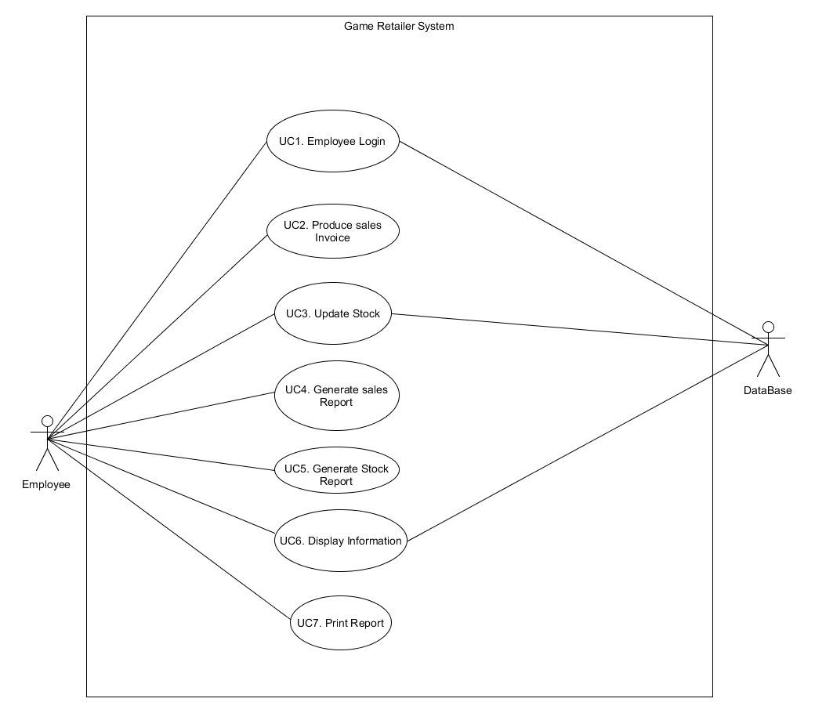

### 2.3.3 Initial use case descriptions

**Use case 1 – Employee log in (FR1)**

When ever the user loads up the application, they will be required to log in they must have valid log in. Details that are stored in the system. The log in will consist of their employee number and a password.

**Use case 2 – Produce sales Invoice (FR2)**

After each sale the employee will be able to generate a sales invoice the invoice will show the name of the product that was purchased the first and last name of the person who made the purchase their address, email address the cost of the product they bought, and the application will assign an invoice id to the invoice.

**Use case 3 – Update Stock (FR3)**

The user will be able to update the stock that they sell they will be able to do this by updating the information in the database using the program.

**Use case 4 – Generate Sales Report (FR4)**

The user will be able to produce a range of reports detailing their daily, weekly, monthly, quarterly, annual sales and vat analysis.

**Use case 5 – Generate Stock report (FR5)**

The user will be able to generate reports about their stock turnover and stock outages.

**Use case 6 – Display Information (FR6)**

The user will be able to display a list of information that is stored in the data base about their customers, products, suppliers and invoices.

**Use case 7 – print report (FR7)**

The user will have the option for any of the reports that have been generated by the application to be printed out.

### 2.3.4 Design stage use case descriptions

During the design phase I will be taking the top-level use case and creating a more detailed version of the use case model it will contain more details about what each of the use cases can do I will also be creating sub diagrams for each use case as well. I will be creating use case descriptions for each use case which will show how they will work in the application.

# **3 Information gathering techniques**

I will be utilizing several techniques to help me clarify the brief given to me and also the systems functional and non-functional requirements to achieve this I will be carrying out several forms of information gathering this will range from having interviews with the client asking questions about how the current system the company uses functions, handing out questionnaire to the client or using them to get a wide range of feedback. I will also be performing research about similar applications to get an idea of how the application could potentially function and to get ideas of how the user interface could look.

## 3.1 Client Interviews

During development I will be conducting serval interview with the client to help clarify the brief given to me and any of the functional and non-functional requirements I will be able to ask a series of questions about how their current system works and ask about anything the client wants that was not mentioned in the brief. At some stages of the project I may also have diagrams of how the user interface may look and navigate or an early prototype of the application to show the client.

the way I will be handling these interviews will be to ask the client a series of questions to the clients and taking a note of their answers I also intend to record these interviews to be able to play back the interview so I am table to listen to the interview again and pick up any information That I missed from the client. The reason that I will be conducting these interviews is to hopefully get additional information about what the client would like the system to be. I have already conducted an interview with the client which was helpful to clarify some of the functional and non-functional requirements.

### 3.1.1 Interview questions

Question 1: Would you like the user to require to be logged to use the program?

Yes, Users should be able to log into the system. (FR1)

Question 2: If employees are required to login. how should the employee's login be created i.e. create own user name assigned a username etc

Employees will use their employee id and create a password to log in. (NFR11)

Question 3: How many employees do you indeed to be using the system?

Since it is a small company 5 users will be using the system. (NFR15)

Question 4: What kind of system is in place currently?

Currently the company is using a paper-based system that they use to produce the invoices for the transactions, to generate their sales reports, stock reports and to display the information about their customers, products, suppliers and the invoices for each purchase.

Question 5: What information do you store currently?

* **Customers**

The information that is currently stored about their customers is the customers id, their first name, their last name, their address, their email address and the customer is given the option if they want to give their phone number as well. (NFR16)

* **Products**

The information that is currently stored about the games the company sells is the name of the product, the cost of the unit, the release date of the game, an image of the game, the platform the game is on, a brief description about the game and the product id. (NFR16)

* **Suppliers**

The information that is currently stored about theirs supplies is the supplier name, suppliers address and the supplier id. (NFR16)

* **Invoice**

The information stored about each invoice is the first and last name of the customer who made the purchase, the address of the customer, the customers email address, the name of the product they purchased, what plat form they bought the game for, the cost of the game including vat and the invoice id. (NFR16)

Question 6: Do you have a colour scheme in mind that you would like to be used?

The colour scheme is required to consider colour blind people therefore the colour scheme is required to use pastel colours on the background meaning that it should not use bright colours and the text should be easy to read on the background use therefore black or grey text is what should be used. (NFR4)

Question 7: Clarification on what is meant by being able to update stock in real time

Admin will be able to set the stock level if stock reaches 0 a message will be displayed to the admin informing them that the item is longer in stock (NFR8) the application should also inform the admin when the stock level reaches three or less displaying a message that the item count is low. (NFR9)

Question 8: Clarification of what specification the computers have

The computers are running on windows 10

## 3.2 Research performed on similar applications

During the development of the application I will be researching other applications that perform similar task to the one that I am creating the reason that this is a useful information gathering technique is because I will be able to look at these applications to give inspiration on how I could design the user interface of the application and to get an idea of how the application could function.

One of the applications that I had a look at is Xero <https://www.xero.com/uk/> It is an application that is used by small businesses that is very easy to use to produce simple user friendly invoices the application is similar to the application that I am creating it allows you to keep track of stock in real time I had a look at how they designed their user interface to give me ideas of how the reports and information that will be displayed could look the application also has an invoicing feature that I had taken a look at to get an idea of how the template that I create for the application could display the information.

Another application that I looked at was wave <https://www.waveapps.com/> this is another system that can be used to produce invoices. This is a free application that allows you to pay for additional features is useful for small businesses in this way as you only pay for what you need the application has a highly customisable clean easy to use user interface which produces invoices.

Another Application that I done some research on was <https://www.freshbooks.com/projects-and-collaboration> this is an application that tracks invoicing for small businesses it allows for customization of the user interface and allows invoices to be sent electronically or allows them to be printed.

Another application that I looked at was Deskera ERP <https://www.deskera.com/erp/> This is an piece of software runs on windows (xp and newer) it can be used to display financial information about a company it can also be used to manage stock the application also allows reports to be printed.

I also had a look at the game website <https://www.game.co.uk/> to see what kind of information they display about the games that they sell and how it is displayed to users.

## 3.3 Questionnaires

Another form of information gathering I will be using during the project is to hand out questionnaires which will be directed towards a larger range of the applications target audience to get a wide range of feedback on what people like about the application and what people dislike about the application or to be directed towards the client that the application is being built for.

During interviews I have with the client I may also give them a questionnaire at the end of the interview To get information about what they think of the current state of the application and also to ask them what the consider the most important part of the application is and what is least important to get an idea of where most of the development time should be focused.

I will be creating questionnaires each phase of the development of the project as away to gather information to help with the development of the application.

During the interpretation phase I have created a questionnaire to get an idea of how important each feature the application will include. So that I can get a general idea of where I should focus the most development time.

### 

### 3.3.1 Questionnaire description for client

The purpose of this questionnaire was to get feedback on what the client specifically thinks is the most important features in the application so that I can get an idea of what features I should prioritize working on for the application.

### 3.3.2 Questionnaire Description – for wider audience

Along with the questionnaire that I created to give to the client I also created a questionnaire to give to a wider audience to get a broad range of feedback from people who may use the application.

The template that I created first gave the potential user a brief description of the application then I asked a series of questions to get feedback on what they think of the application.

### 3.3.3 Questionnaire form – for client

Question 1: on a scale of one to ten how important is the ability to produce sales reports

Question 2: on a scale of one to ten how important the ability is to produce a sales invoice after each transaction

Question 3: on a scale of one to ten how important the ability is to generate stock reports

Question 4: on a scale of one to ten how Important to have the ability to view the details that are being stored

Question 5: On a scale of one to ten how important do you consider the print feature.

### 3.3.4 Description of the application for the questionnaire

The purpose of the application is to help a small business manage their sales and stocks the application will be able to produce a range of reports that display sales reports the application will also be able to manage the stock the company hold giving the user a warning if there is a low amount of an item and if the item is out of stock.

The application will also be able to produce a sales invoice for each sale that the company makes. The application will also allow any information that the company stores about their clients, product, supplier and sales invoices to the screen. Any report that the application creates will give the user to either view the report on screen or allow them to print the report.

### 3.3.5 Questionnaire form – for wider audience Template

Question 1: How old are you?

Under     18– 20    21 – 30    31 – 40    41 – 50   Over 51

Question 2: What is your gender?

Male Female Other Prefer not to Say

Question 3: Do you currently work with a small business

Yes No

Question 4: What operating system do you use

Windows Linux Mac OS X Other

Question 5: on a scale from one to ten how likely are you to use the feature that produces sales reports.

Question 6: On a scale from one to ten how likely are you to use the feature that allows you to manage stock

Question 7: on a scale from one to ten how helpful do you think the feature that warns the user if the stock on an item reaches a low quantity.

Question 8: On a scale from one to ten How likely are to use the feature that produces sales invoices after each transaction.

Question 9: On a scale from one to ten how likely are you to use the feature that allows you to display the details that are being stored about clients, products suppliers and invoices

Question 10: On a scale from one to ten how likely are you to use the print feature included in the application

Question 11: What way are you most likely to view the reports generated

On screen Printed

Question 12: Is there any additional feedback that you would like to give about the application

### 3.3.6 Questionnaire form – for wider audience Finalized

After creating the template for the questionnaire, I used google docs to create the questionnaire which makes it easier to keep track of all the feedback received from the questionnaire

<https://goo.gl/forms/CJoXpIg6rQWu2xXz2>

### 3.3.7 Questionnaire - feedback

Using the feedback from the questionnaire It has given me an idea of what features in the application that range of people would think is useful. Google docs breaks down each of the questionnaires I asked in to easy to read diagrams with what people answered.

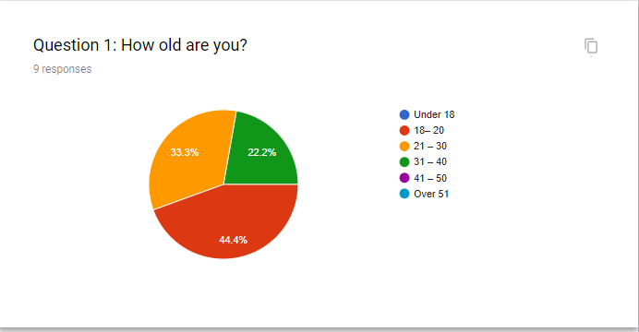

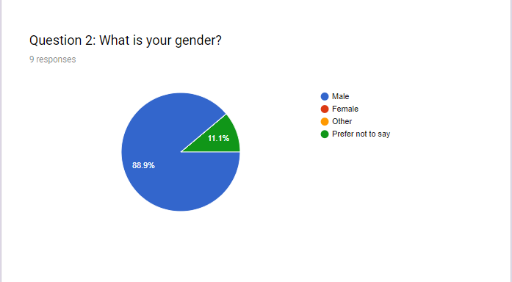

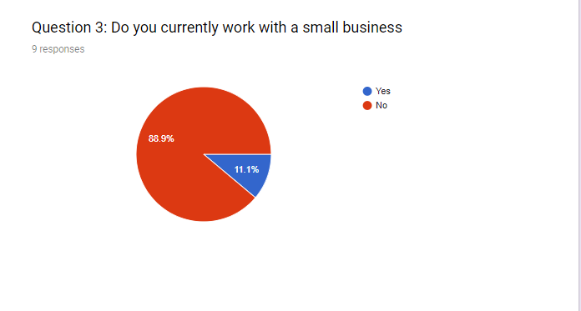

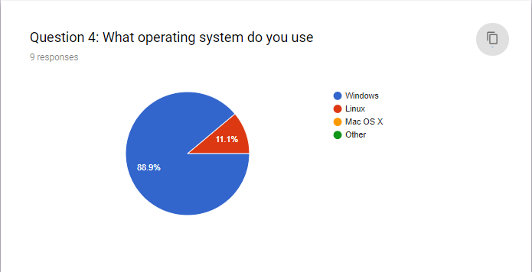

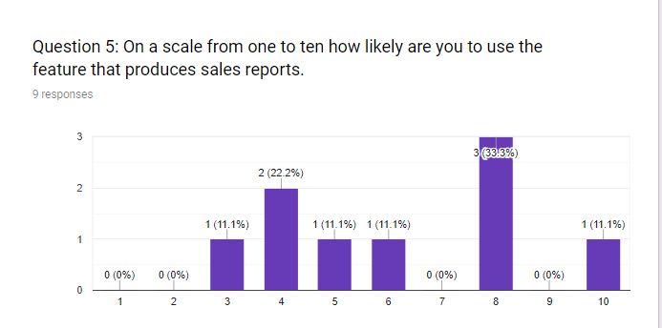

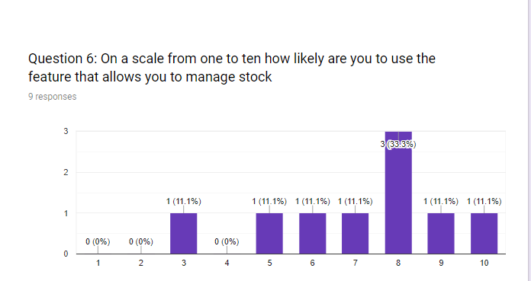

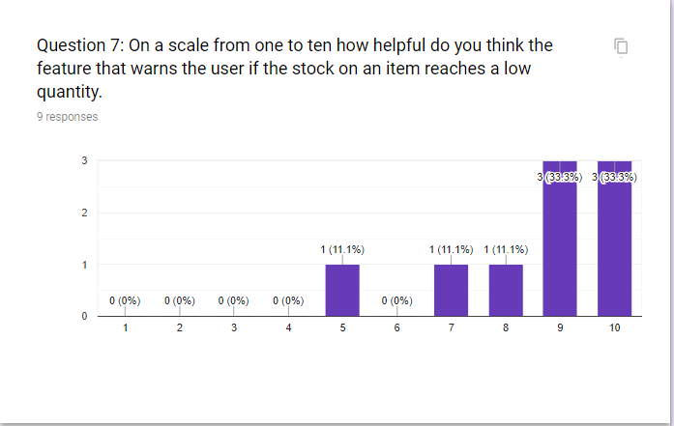

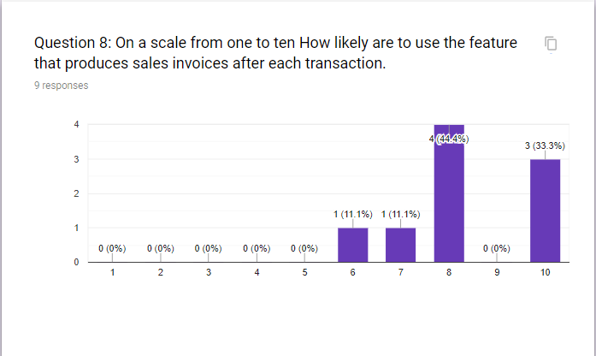

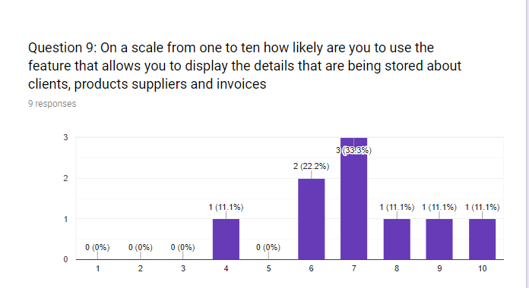

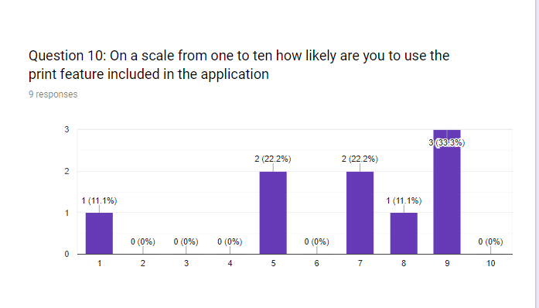

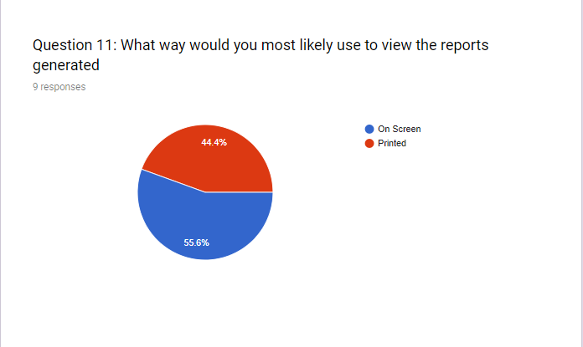

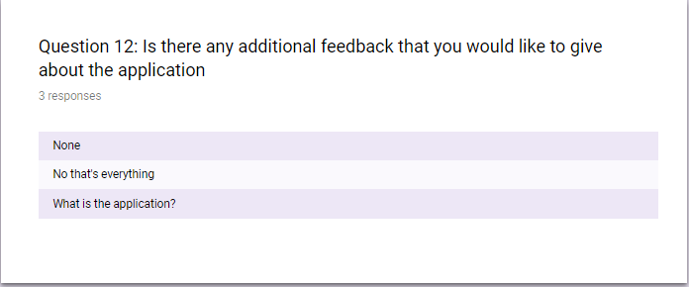

# **4 Project aim**

The Primary aim of the project is to build a working prototype of the application before 24/05/2019 that meets the requirements that were specified in the brief and functional and non-functional requirements.

The prototype of the application will contain a functional user interface with a colour scheme that matches the requirements of the client and will be clear and simple to navigate. The application will be able to display a range of reports about the companies sales, the application will also show the levels of stock they have in real time if any of their stock is low messages will be displayed informing the admin that they are out of stock of an item reaches zero or running if the stock of an item reaches three or less,

The application will also be able to display a range of information about their current customers, products, suppliers and invoices. Along with the prototype I will also be creating user documentation to go along with the application with instructions for new users on how to use the application.

The application will produce simple reports which will be displayed to the screen and give the user and option to print the reports generated.

# **5 Resources and materials required**

## 5.1 Hardware

**Desktop Computer** – I will need a computer to be able to run any of the software that I will be using during the development of the project and is required to be able to build the application and to test the software. I have access to a computer at home and am also able to use the computers that are at the college.

**Internet Connection** – I Will require a connection to the internet to during the development of the project to be able to research information about Integrating the data base into the project. As well as being able to perform research on solutions to issues that I encounter during the development of the software an internet connection is also required to be able to access some of the software that I will be using during the project. I Have internet access at home as well as being able to use the college internet

**Usb** – I will be using a usb to keep a backup of the project and I will also be able to keep the project stored on the usb to transfer it from my home computer to be able to continue working on the project when I am at college.

**Printer** – I will require a printer as the application is required to give the user an option to receive a hard copy of the information that is produced by the program. I will require a printer during the testing phase of the project to ensure that no issues are found when printing the information produced by the program. I will have access to a printer at the college.

**Phone** – During interviews with the client I want to be able to record them so that I can listen to them to get any information that I missed during the interviews I have a phone that I can use.

## 5.2 Software

**Data Modeler** – I will be using the software to create an ERD for the data base and to assign the data type that will be used for each column in the data base I have access to data modeler from my home computer and the college computer.

**Microsoft project** – I will be using Microsoft project to produce a Gantt chart to help me manage my time effectively by planning out the project and setting deadlines for how long each section should take to complete I can also use this to allocate what resources I will be using at each step of the project. I am able to get this for free from the e5.onthehub website I am able to access this from home or on the college computers.

**Office 365** – I will be using one drive of office 365 to keep a backup of the project and to also transfer the project from my home computer to the college computer.

**Microsoft Word** – I will be using Microsoft word to Keep the documentation of each stage of the project together. I will be also using word to produce separate documentation that cannot be produced by any of the other pieces of software that I am using I have access to Microsoft word for free since I have a student account on office365 I am able to access this on my computer at on and on the college computers.

**Google chrome** – chrome I my internet browser of choice I will be using it during the project to perform any of the research I will be doing during the development of the application and also to access some of the other software I will be using during the development of the project I have access to chrome as a free download so I am able to access chrome at home or at the college.

**Scene builder** – I will be using scene builder to build the graphical user interface in java fx. I am using this software as it allows me to simply drag and drop elements of the user interface rather than hand writing each element of the user interface this will allow me to save time during the development of the user interface. I can download load scene builder for free, so I am able access this on my own computer and at the college.

**Windows 10** – the operating system that the client’s machines runs on is windows 10 therefore I will need to test the application to ensure that it works properly on windows 10. The operating system my computer uses is windows 10 so ill be able to access it at home.

**Eclipse** – I will be using eclipse as my Integrated development environment the reason that I choice to use this over other IDES is because it is the one that I am most familiar with and know that It has all the features I will require during the development of the project I will be using this to write the code required to build the application and also part of the testing phase will be done using eclipse. Since eclipse Is a free download, I have access to eclipse on my computer at on and at the college.

**phpMyAdmin** – I will be using phpMyAdmin to build the database that will hold the information that is required to be stored this will insure that when the program is switched off none no data is lost, I will be able to access this on my own computer or at the college.

**Java Data Base Connectivity (JDBC)** – JDBC Will allow me to form a connection from the data base I created to the java program I will be able to access this for free on my own computer and on the college computer

**Uwamp** – I will be using uwamp as this will act as a local server for the database to run on, I will be able to access this on my own computer or at the college.

**Umlet** – I will be using umlet to create any of the diagrams I will produce during the project I am able to access this at home and as well as the college

**Moqups** - I will be using moqups to produce wireframes for the programs graphical user interface I have access to this from home as well as the college.

**Paint.net** – I will be using paint.net for any images that I need to edit for the application I am able to download paint.net for free and am able to access it on my own computer.

**Google docs** – I will be using google docs to create the questionaires that I will be making during the development process. I will be able to access this at home or on the college computers

## 5.3 Materials

**Pen** – I will need a pen during the project to use to take any notes that I am writing that are not on the computer I already have spare pens that I can use.

**Paper** – I will need paper to be able to be able to take notes during interviews I will also need paper to test the print function of the application I also may use paper to draw some of the diagrams that I will be making.

**Chair** – I will need a chair to sit on when working on the application I have A chair that I can use and there are also chairs at the college.

## 5.4 Books, journals, tutorials

<https://www.w3schools.com/sql/default.asp> - I will be using the to help me with any of the sql commands that I am struggling with. I will be able to access this website on my own computer or using the college computers.

<https://dev.mysql.com/> - I will be using the mysql website to help me set up the connection to allow my java program to connect to the date base I will be able to access this website on my own computer or using the college computers.

<https://docs.oracle.com/en/> - I will be using the oracle docs website to help me set up my data base and to also help me also use the information that was retrieved from the data base in my java program. I will be able to access this website on my own computer or using the college computers.

<https://docs.oracle.com/javase/7/docs/api/> - I will be using this website to help find any library that may be useful during the development of the application I will also be using this to produce java docs I will be able to access this website on my own computer or using the college computers.

<https://www.siteground.com/tutorials/phpmyadmin/> As I am new to using phpMyAdmin I will be using a tutorial on how phpMyAdmin works to get a proper understanding of how the features work I will be able to access this website on my own computer or at the college.

<https://docs.oracle.com/javafx/2/get_started/jfxpub-get_started.htm> - As I am unfamiliar with using javaFx I will be looking through some tutorials to get an idea of how to use it I will be able to access this website on my own computer or at the college.

<https://code.makery.ch/library/javafx-tutorial/part1/> - As I am unfamiliar with using scene Builder, I will be looking through a tutorial to get an idea of how to use it I will be able to access this website on my own computer or at the college.

<https://stackoverflow.com/> - I may use stack over flow during the development of the application to find solutions to parts of development I am having issues with I will be able to access this website on my own computer or at the college.

<https://www.youtube.com/> - I may use youtube as way to find tutorials for problems that I encounter during development I will be able to access this website on my own computer or at the college.

# **6 Deliverables**

## 6.1 Documentation for feasibility meeting

(6th of February 2019)

The documentation that I produced to take to the client was my interpretation of the brief given to me by the client this included a range of solutions that could have been potentially used and the decision I came to on what solution would be the best to carry out the development of the application after showing the document to the client I carried out an interview to get a better understanding of what they want developed.

## 6.2 Inception phase report

(15th of February 2019)

This report will detail the aim of the project, my final interpretation of the brief and how I think the application will function based on the interview I had with the client.

The report will include a range of functional and non-functional requirements a top-level use case. It will also detail any research I performed to help me get a better understanding of how the application should work. This report will include the aim of the project and a list of what materials I will require during the project ranging from the necessary hardware and software to what information sources I intend to use.

## 6.3 User Interface design wireframes

(22nd of February 2019)

For the next client interview I intend to have a range of wire frame that will detail how the user interface will work this will include how you will navigate the application and a range of different colour schemes to give the client and allow them to pick the one that they like the most.

## 6.4 Solution Phase Planning report

(1st of March 2019)

This report a more detailed use case diagram which will also include sub diagrams for each use case and creating use case descriptions which will detail how each of the use cases will work this report will also include the final design for the user interface. I will also be designing the erd to be used for the data base in the system.

## 6.5 Application prototype

(10th of April 2019)

During the development stage of the application I will be creating a basic prototype of the application to show the client during one of the meetings to show them how the application is coming along this prototype will include the user interface and contain some of the basic functions the application will perform.

## 6.6 Development stage documentation

(3rd of May 2019)

This documentation will contain information about the different types of testing that were carried out during the testing phase of the development process it will also contain user documentation with instructions about how to use the application it will also contain the java docs produced.

## 6.7 Evaluation Report

(17th of May 2019)

This documentation will contain an evaluation about how the project went it will include an outline of how the project compared to the original requirements. the document will also assess what my strengths and weaknesses were during development. The report will detail a summary of any changes that had to be made during developments and way the changes had to be made, anything that went wrong during the project and how they it was handled and what could be done to make the project go smoother.

# **7 Information sources**

Bromley, S. (2018, January 12). *The best invoice apps for small businesses: 7 apps to make your life easier*. Retrieved Febuary 11, 2019, from www.simplybusiness.co.uk: https://www.simplybusiness.co.uk/knowledge/articles/2018/01/best-invoice-app-for-small-businesses/

code.makery. (2019, Febuary 11). *javafx-tutorial*. Retrieved Febuary 11, 2019, from code.makery.ch: https://code.makery.ch/library/javafx-tutorial/part1/

Fox, L. (2018, June 22). *Advantages And Disadvantages - Web Apps*. Retrieved Febuary 10, 2019, from www.objectiveit.com: https://www.objectiveit.com/blog/the-advantages-and-disadvantages-of-web-apps

Game. (2019, Febuary 11). *Game*. Retrieved Febuary 11, 2019, from www.game.co.uk: https://www.game.co.uk/

MYSQL. (2019, Febuary 11). *dev.mysql*. Retrieved Febuary 11, 2019, from dev.mysql.com: https://dev.mysql.com/

Oracle. (2019, Febuary 11). *docs.oracle*. Retrieved Febuary 11, 2019, from docs.oracle.com/en/: https://docs.oracle.com/en/

Oracle. (2019, Febuary 11). *Getting Started with JavaFX*. Retrieved Febuary 11, 2019, from docs.oracle.com: https://docs.oracle.com/javafx/2/get_started/jfxpub-get_started.htm

Oracle. (2019, Febuary 11). *Java Platform stanadard Edition 7 API Specification*. Retrieved Febuary 11, 2019, from docs.oracle.com: https://docs.oracle.com/javase/7/docs/api/

Rehman, J. (2017, November 1). *advantages-disadvantages-graphical-user-interface*. Retrieved Febuary 10, 2019, from http://www.itrelease.com: http://www.itrelease.com/2017/11/advantages-disadvantages-graphical-user-interface/

SiteGround. (2019, Febuary 11). *phpMyAdmin Tutorials*. Retrieved Febuary 11, 2019, from www.siteground.com: https://www.siteground.com/tutorials/phpmyadmin/

Software Advice. (2019, Febuary 11). *Deskera ERP Software*. Retrieved Febuary 11, 2019, from deskera.com/erp/: https://www.deskera.com/erp/

*SQL Tutorial*. (2019, Febuary 11). Retrieved Febuary 11, 2019, from www.w3schools.com: https://www.w3schools.com/sql/default.asp

Stackoverflow. (2019, Febuary 11). *stackoverflow*. Retrieved Febuary 11, 2019, from stackoverflow.com: https://stackoverflow.com/

Xero. (2019, Febuary 11). *www.xero.com*. Retrieved Febuary 11, 2019, from www.xero.com: https://www.xero.com/uk/

Youtube. (2019, Febuary 11). *Youtube*. Retrieved Febuary 11, 2019, from https://www.youtube.com/: https://www.youtube.com/